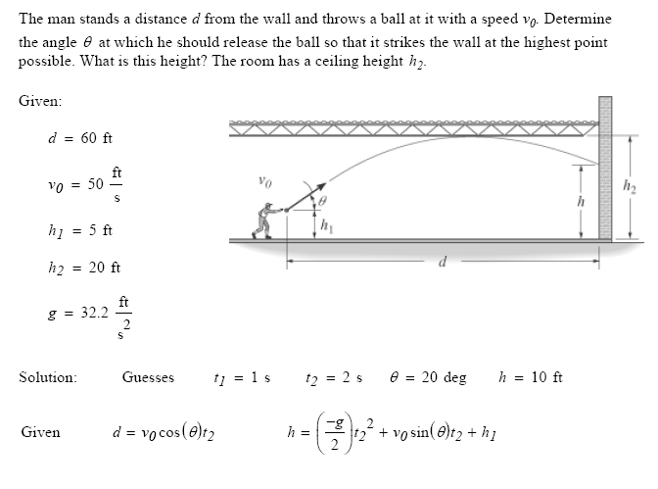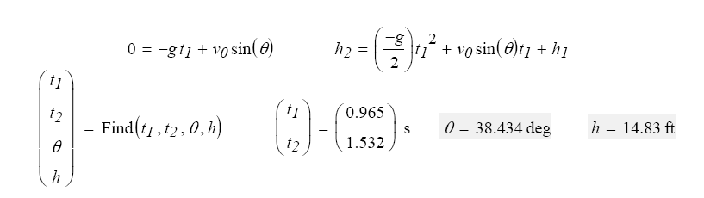

If they are released from rest
Find the distance traveled by A after 5s
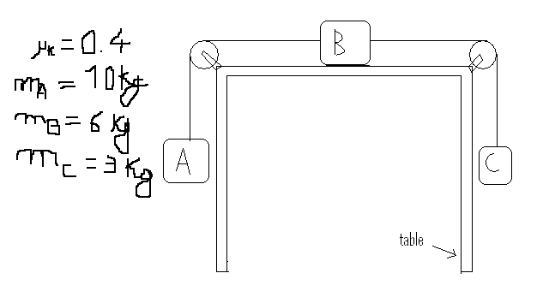
Sol:
WA – Wc - µWb = ( ma + mb + mb) a
- a = ….
- Distance = …..

